Azure Extensions

In order to make the Windows Azure IaaS VMs customizable, Windows Azure is releasing a set of capabilities which will enable users to automate software deployment and configuration on IaaS VMs. As a part of these capabilities, a protocol is being released which can be used by various existing VM customization products to integrate with the Windows Azure VM ecosystem. This document discusses the requirements to participate in Windows Azure VM ecosystem and provides a guide for integrating VM customization products with Windows Azure.

Terminology

Windows Azure Agent - The Windows Azure component that runs inside the VM and is responsible for managing the extension handlers.

Handlers - Partner authored component to deliver software and configuration to the customer VM. This component needs to implement handler configuration and status contracts and be provided as a handler package. Generally a handler will consist of an Azure interoperability wrapper around an existing VM customization product.

Extension Pack - Specific job, workload, or script to be executed by the extension handler.

Handler identity - An identifier used to uniquely define the handler. This identity is a tuple of <Handler name>, <Publisher> and <Version>

Handler Manifest - A JSON based manifest that defines various properties needed by the Azure Agent to manage the handler.

Requirements

To participate in the Windows Azure ecosystem, any VM customization product needs to create a handler that implements the Windows Azure Agent defined protocol to integrate with the Azure ecosystem. The basic requirements for creating a handler that implements the Azure protocol are:

- Handler Packaging – The Handler should be packaged as a zip file. This zip package should contain all the binaries related of the handler and HandlerManifest. This package needs to be registered with the Azure image repository. Azure image repository is responsible for managing all versions of all the handlers that are registered with the Azure ecosystem.

- Handler Environment - Handler needs the capability to read the environment file in the format that Azure Agent defines. The environment file defines the locations of various files and folder that the handler needs to use for reading configuration and writing back heartbeat and status.

- Handler Configuration – Various extension packs that the handler needs to manage are passed to the handler in form of configuration settings. For example if a script is needed by the handler to install an extension, that script is passed to it via the handler configuration file. The handler should have the ability to read this file in the format defined by the Azure Agent and should be able to execute its contents and report the status of that execution with a frequency that complies with the Azure Agent protocol.

- Handler heartbeat and status – The handler is supposed to report the status of the most recently executed configuration with a frequency that complies with the Azure Agent protocol.

Architecture

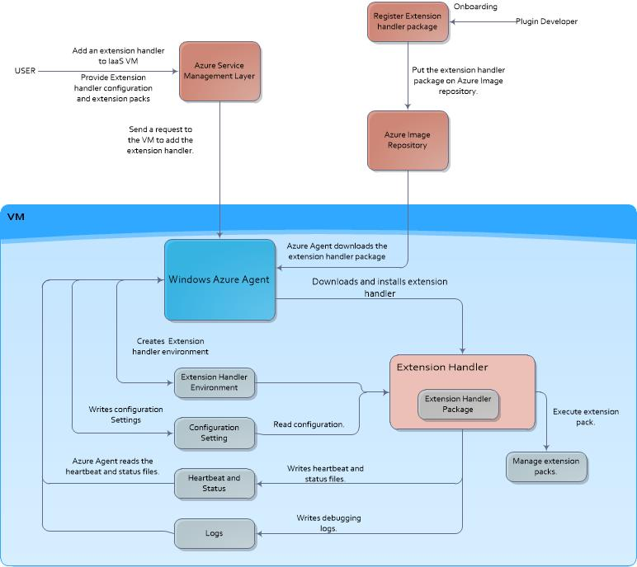

An Azure Extension Handler is composed of the following artifacts:
- Handler Package: This is the package that contains your Handler binary files and all standard static configuration files. This package is registered with the azure ecosystem.

- Handler Environment: This is the set of files and folders that the Azure Agent sets up for the Handlers to use at runtime. These files can be used for communicating with the Azure Agent (heartbeat and status) or for writing debugging information (logging). The details of handler environment created by the Azure Agent is discussed in section 2.1.1.2 below.

- Handler Configuration: This is a configuration file that contains various settings needed to configure this Handler at runtime. Extension configuration is the input provided by the end user based on the schema provided by the handler publisher during registration. For example, a handler might get the client authentication details for writing logs to his storage account via the handler configuration.

Questions:

1. What causes that n.setting file to be written?

=> The perimeters we pass in our deploy.parameter file are saved here. Means all the things like our private key,node name,bootstrap version are stored here.

2. Where it is written?

=> inside the packages folder

3. At what point we take a backup?

=> when we update the chef extension at that time we take a backup of chef configurations so after backup it uninstalls it and than again it installs the extension with the configurations as saved in backup file.

4. What happens when we restart?

=> during enable if our service is installed than we restart it again. in this firstly the service is stopped than it sets the startup type of chef-client service to be automatic and than it starts the chef client.

5. When this file gets refreshed?
=> When we update our extension configurations and then run update command at that time this file gets refreshed. It makes new file like 1.settings,2.settings,3.settings and so on…

Commands and working:

We can add extension through
1. Powershell Commands
2. Azure CLI
3. Azure Xpalt CLI
4. Knife Azure Plugin

POWERSHELL:-
----------------------

1. Login to azure account

CMD – Login-AzureRmAccount

2. Set Subscription ID

CMD - Set-AzureRmContext -SubscriptionID 'e00d2b3f-3b94-4dfc-ae8e-ca34c8ba1a99'

3. Create a Resource Group

CMD - New-AzureRmResourceGroup -Name manikGroup4 -Location "South Central US"

4. Add extension

CMD - New-AzureRmResourceGroupDeployment -Name mgDeployment89 -ResourceGroupName manikUbuntu -TemplateFile 'C:\CHEF\azure\extensions\ubuntu\azuredeploy.json' -TemplateParameterFile 'C:\CHEF\azure\extensions\ubuntu\azuredeploy.parameters.json'

AZURE CLI:-
–----------------
----------------------------------------------------------
| Install Azure CLI |
----------------------------------------------------------

1. Login to azure account through command

CMD – az login

2. Create a group (resource-group)

CMD - az group create --name MgEXTENSIONS --location "South Central US"

3. Create a vm

CMD - az vm create --name 'MgWindowsazure' --resource-group 'MgEXTENSIONS' --image Win2016Datacenter --admin-username 'Manik' --admin-password manikmaster#123

4. Fetch all the extension name with publisher list and versions...
## Find list all extensions and select from that list which extension is suitable for your vm image

CMD - Get-AzureVMAvailableExtension | Select ExtensionName, Publisher, CompanyName, Description | Out-gridView

##EXAMPLE

CMD - Get-AzureVMAvailableExtension -ExtensionName Windows -Publisher Microsoft.Azure.RecoveryServices.SiteRecovery -AllVersions | select ExtensionName,Publisher,Version

5. Set extension to created vm

CMD - az vm extension set -n ChefClient --version 1210.12.110.1000 --publisher Chef.Bootstrap.WindowsAzure --vm-name 'Manik' --resource-group mgGarg5

|OR|

CMD - az vm extension set -n Windows --version 1.0.0.8 --publisher Microsoft.Azure.RecoveryServices.SiteRecovery --vm-name 'MgWindowsa' --resource-group ManikGroup52

|OR|

CMD - az vm extension set -n Windows --version 1.0.0.9101 --publisher Microsoft.Azure.RecoveryServices.SiteRecovery --vm-name MgWindowsazure --resource-group MgEXTENSION

AZURE XPALT CLI:-
---------------------------

----------------------------------------------------------
| Install Azure XPALT CLI |
----------------------------------------------------------

1. Login to azure account through command

CMD - azure login

2. Create a vm (create vm like with port number or create it manually on portal)
Syntax - azure vm create -n name -g resource_group -Q publisherName:offer:skus:version -u username -p password

Example:
CMD - azure vm create -n 'MgWindowsazure' -g 'MgEXTENSION' -Q MicrosoftWindowsServer:WindowsServer:2012-R2-Datacenter:latest -u 'manik' -p 'manikmaster#123' -f 'mgNicName'

After you fire this command powershell will prompt you to enter following details which we can take from the portal.
Location name
Operating system Type
Enter vnet name
Enter vnet subnet name

THESE We CAN TAKE FROM PORTAL:

Location name: South Central US
Operating system Type: windows
Enter vnet name: MgWindowsazureVNET
Enter vnet subnet name: MgWindowsazureSubnet

3. SETTING EXTENSION

CMD - azure vm extension set-chef -g ashGroup2 -m ash-ubuntu -C Assignment_2/chef-repo/.chef/manikafsgarg.pem -c Assignment_2/chef-repo/.chef/knife.rb --bootstrap_version "13.8.5"

KNIFE AZURE PLUGIN :-
---------------------------------

----------------------------------------------------------
| Install knife azure gem |
----------------------------------------------------------

1. ASM mode (It installs extension through bootstrap-protocol option)

CMD - knife azure server create --azure-vm-size 'Medium' -I 'b39f27a8b8c64d52b05eac6a62ebad85__Ubuntu-16_04-LTS-amd64-server-20180418-en-us-30GB' --azure-service-location 'West US' -x 'azureuser' -P 'azure@123' --bootstrap-protocol 'cloud-api' -c '..\.chef\knife.rb' -N 'manikazure'

OR

CMD - knife azure server create --azure-vm-size 'Medium' -I 'a699494373c04fc0bc8f2bb1389d6106__Windows-Server-2016-with-Containers-20180315-en.us-127GB.vhd' --azure-service-location 'West US' -x 'azureuser' -P 'azure@123' --bootstrap-protocol 'cloud-api' -c 'B:\chef-repo\.chef\knife.rb' -N 'manikazure'

2. ARM mode (In ARM mode it automatically installs extension)

CMD - knife azurerm server create --azure-resource-group-name 'MgEXTENSIONS' --azure-vm-name 'mga-21' --azure-service-location 'westus' --azure-image-os-type 'windows' -x 'myuser' -P 'master#123' -c 'B:/chef-repo/.chef/knife.rb' --bootstrap-version '13.8.5' --bootstrap-channel 'stable'
OR

CMD - knife azurerm server create --azure-resource-group-name 'MgEXTENSIONS' --azure-vm-name 'mga-22' --azure-service-location 'westus' --azure-image-os-type 'ubuntu' -x 'myuser' -P 'master#123' -c 'B:/chef-repo/.chef/knife.rb' --bootstrap-version '13.8.5'

PATH OF EXTENSION FILES:

Note imp: chef extension code is present in this gem path this use to modify the code on vm:
1) In windows:
C:\opscode\chef\embedded\lib\ruby\gems\2.3.0\gems\azure-chef-extension-0.0.1\lib
2) In Ubuntu :
/opt/chef/embedded/lib/ruby/gems/2.3.0/gems/azure-chef-extension-0.0.1/lib

AND then run enable cmd from path :

1) In windows:
C:\Packages\Plugins\Chef.Bootstrap.WindowsAzure.ChefClient\1210.12.109.1003
2) In Ubuntu:
/var/lib/waagent/Chef.Bootstrap.WindowsAzure.LinuxChefClient-1210.12.106.1002

